

Cass-Q Software Architecture Document

Document File Name | 0000.doc
Version | 1.0
Version Date | July-2009
Author | Iván Kubinyi

Revision History

Date | Version | Description | Author
11-Mar-2009 | 1.0 | Preview release | Iván Kubinyi

Table of Contents
1 Introduction 5
1.1 Purpose 5
1.2 Scope 5
1.3 Intended Audience 5
1.4 Definitions, Acronyms, and Abbreviations 5
1.5 Issues 6
1.6 References 7
2 Architectural Goals and Constraints 7
2.1 System Context 7
2.2 Architectural Principles 8
2.3 Architectural Patterns 8
2.4 Reference Architecture 9
2.5 Assumptions 9
2.6 Technology, Services & Middleware 9
2.7 Interfaces and Protocols 9
3 Quality Considerations and Decisions 11
3.1 Usability 11
3.1.1 Localization 11
3.1.2 Personalization 11
3.1.3 Accessibility 11
3.2 Reliability 11
3.2.1 Availability 11
3.2.2 Recoverability 12
3.2.3 Fault Tolerance 13
3.2.4 Integrity 13
3.2.5 Accuracy 13
3.3 Security 13
3.3.1 Authentication 13
3.3.2 Authorization 14
3.3.3 Confidentiality 14
3.4 Efficiency 15
3.4.1 Speed and latency 15
3.4.2 Capacity 16
3.4.3 Scalability 16
3.5 Maintenance 17
3.5.1 Software Maintenance 17
3.5.2 System Maintenance 17
3.5.3 Migration 17
3.5.4 Testability 18
3.5.5 Installability 18
3.5.6 Adaptability 18
3.5.7 Flexibility & Configurability 18
4 Use-Case View 18
5 Logical View 19
5.1 Overview 19
5.2 Business Domain 20
5.2.1 Domain Models 20
5.2.2 Business Workflows 20
5.3 Layers & Packages 21
6 Process View 22
6.1 Overview 22
6.2 Process descriptions 23
7 Implementation View 24
7.1 Design Packages 24
7.2 Component Model 26
8 Deployment View 27
8.1 Deployment Unit Structure 28
8.2 Infrastructure components 29
8.3 Topology 30
9 Data View 30
9.1 Database Explained 30
9.1.1 Users 30
9.1.2 Researches 31
9.2 Structure of the Code 33
9.2.1 Classes 33
9.2.2 Authorization, Includes 33
9.2.3 User Interface 33
9.2.4 Communicating with phone 33
9.2.5 Settings and Installation 34
10 Design Constraints 35
10.1 Design Patterns 35
10.2 State Management 35
10.3 Persistence & Data access 35
10.4 Caching 36
10.5 Concurrency &Transactions 36
10.6 Input validation 37
10.7 Security 37
10.8 Reporting & Printing 38

Introduction
The Cass-Q Software Architecture Document outlines all the key design decisions made in creating the Cass-Q Admin system. The CASS-Query tool has been developed in the KP-Lab project (http://kp-lab.org). The KP-Lab Integrated Project is sponsored under the 6th EU Framework Programme for Research and Development.

Purpose
This document provides a comprehensive architectural overview of the system, using a number of different architectural views to depict different aspects of the system. It is intended to capture and convey the significant architectural decisions which have been made on the system.

Scope
The Cass-Q has UI to support following tasks:
- Creating research and defining the collection method of it.
- Adding different queries to the research and assigning questions to the queries.

- On the mobile client the respondent can answer the questions.

- Using the admin tool, the research administrator or the researcher can retrieve the data collected during the research in Excel format.

- Access: At the moment, the Cass-Q admin website is accessible

- Registering: To be able to use the Cass-Q admin site one has to be registered by some existing users. In the initial phase a super administrator role is set up, he or she can register new users to the system. There are different roles in the Cass-Q system. Existing users can add new users with the same or less rights as their originals. Respondents cannot enter the Cass-Q admin site, they are only able to answer the questions using the phone client.
- Logging in:
- Only users with sufficient rights are allowed to log into the Cass-Q admin site. These roles are: super administrator, research administrator and researcher.
- Environment: Cass-Q is an external tool consists of the web-based administrator tool and the mobile client for answering the questionnaires.
- Research: Researches are conducted on daily basis within a predefined period of time. During this time every day query or queries are made available for downloading for the mobile client (pull-method). After filling in the queries the answers are sent to the administration site where the collected data is available for downloading.
Research creation: Users, who have sufficient rights for using the administration site, can create researches. First the start and the end date of the research, the data collection method and the number of the queries sent per day have to be defined. After that follows the assigning of questions to the queries.

Definitions, Acronyms, and Abbreviations
- CASS: Contextual Activity Sampling System. The CASS methods and tools provide contextualized data that allow the analyzing and modelling of within person changes across time.
- User: person who uses the system. One can perform various tasks: administering other users (super admin), administering a research (researcher, research administrator) or answering queries.
- Super administrator: A System Administrator can register users, manage user accounts and configure and assign roles to users. Roles can be used to restrict the access individual users have to functionalities of the Cass-Q system. The roles that a system administrator can grant to other users are: super administrator, research administrator, researcher, respondent. It also allows removing existing users.
- Research administrator: user who administers a research in the system. He/she is allowed creating researches, queries and questions. Also the research administrator is the one who can append respondents to an existing research. During or after the research he/she can collect the research data.
- Researcher: this role only allows gathering the collected data.
- Respondent: a person who answers a query using the Cass-Q mobile client. Respondents have to be assigned to the research.
- Query: name of the questionnaires in the Cass-Q system. It is a group of questions that are sent to the respondents’ phone when he/she uses the mobile client application.
- Data collection method: in this version of Cass-Q there are three types of research methods:
  - Fixed time –data collection method: In this method exact times are set when a query is sent. For each time an own query can be made but the same query can be sent many times a day too. Respondents have time to answer the query until next pre-set time kicks in and during this interval the respondent can answer the query only once.
  - Fixed Interval –data collection method: In this method a time is set for the first query of the days, after that the first query can be answered any time. Also, there needs to be set an interval. The respondent can answer the next query after the interval has passed. In fixed interval also many different queries can be sent.
  - Event contingent - data collection method: Only one query is sent and it can be answered as many times as the respondent wants to answer it a day.

Issues
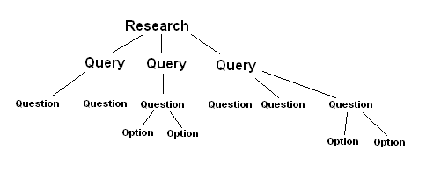
  - At this point of the development of the project the main concept of creating a research is a so called research based. It means that the creation of the research happens in a linear way, from starting defining the research, then the queries and finally the questions.
During the development, because of the problem with getting the research results, it came up that a different approach would be more reasonable to create researches. This method could be called question based. First the research administrator would make the questions and then he/she would organize the different questions under different queries. The research administrator could drag-and-drop the different questions into different queries. The user could even put the same questions into more than one query.
In the later method, the main aim is that the research administrator could define in the beginning in what order the answers of the research would be retrieved. Unfortunately, the in the current version if a question is copied from another query, it automatically gets a different id in the database, thus making the comparison later on too difficult.
Status: OPEN.
  - In the final product, there supposed to be two ways to store the returned media answers. One possibility is to save them directly into the database. The other option is to save them on the server and store only the path to the file. At the present point of the system, it first one is the chosen setting. This is tested and seems functional. Saving the files to disk on the server side is not tested and likely most of the processes are not implemented in that class (DiskFileIO.php).
Status: OPEN.
  - In the database there is little or no constraints when inserting the data. Every checking is done by the PHP processor. No constraints coded in the database.
Status: OPEN.
  - It would be necessary in the further development of the product, if there would be some transaction management in the system. At the present version, when something goes wrong during the research creation there is no way to get back to some saved, stable state. This can cause later on problems.
Status: OPEN.
  - The speed of the database is rather low, especially in when getting back data from the system. Ways to optimize the database should be examined.
Status: OPEN.
  - There should be a separation between active users (basically, respondents and inactive). At the moment if they add new respondents into a research, it usually just creates more users with subject rights. Only the Super Admin can delete from the user list. The information who created the new users should be stored somewhere: probably it would need some redesign in the database side too.
Status: OPEN.
  - When the mobile phone sends back the XML file, it puts the time of the mobile in the XML which gets stored in the database. In the fixed interval researches this causes problem, if the phone is not in the same time zone as the servers which processes the data. For example, if the answer arrives from a Swedish mobile with the Swedish local time, say 23-07-2009 6:00:00, this will be stored as the time of the answer in the tbl_answer table. If the server is in Finland, in the tbl_track_fixed where the time of the answering is stored during the fixed interval researches, the stored time will be one hour more: 23-07-2009 7:00:00. Thus, when the system checks when the respondent can have the next query, it will be allowed just one hour later.
Status: OPEN.
  - During fixed interval research, when the respondent wants to answer the next query in the sequence after midnight (server time), the system will not allow it, even the daily start of the research is set to a later time (like 6 AM or so). The getNextQuery function in SubjectSQLQueryer.php checks if the time when the respondent wants to get the query is a valid time. At one point the function checks if the last time when the query has been answered is on the same day as the checking is happening. Maybe it would worth to check only that the checking time is before the first time when query is allowed to be sent.
Status: OPEN.

References
Ref. | Title | Author | Version | Date
[1] | D6.6 M33 specification of end-user applications –  CASS-Q  D6.6_SpecsForUseCases_CassQAdmin.doc | Iván Kubinyi | 1.0 | 2009

Architectural Goals and Constraints

The Contextual Activity Sampling System (CASS) methodology and CASS-Query tools have been developed for the investigation of learning and working practices. The CASS methods and tools provide contextualized data that allow the analyzing and modelling of within person changes across time. The system makes it possible to collect big amount of data in a short time and collect the research data in an organized manner.
Cass-Q is an external tool for conducting questionnaire based researches. For conducting researches one has to create a questionnaire using the Cass-Q admin website and the respondents have to answer them using the Cass-Q mobile client. The questions are grouped in queries (questionnaires) and the queries are part of the research.
The main aim is to create questionnaires that the respondents have to fill in every day during the time of the research. The numbers of the questionnaires and the interval they are sent can be set.

System Context
The development includes both the mobile application and the web-based application.
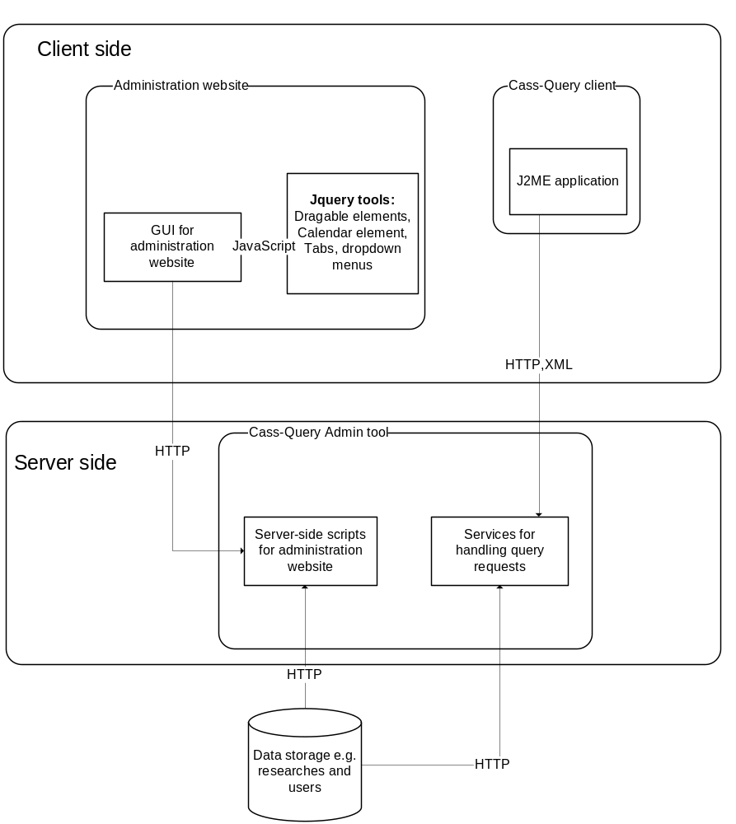
The Cass-Q system consists of the mobile client, which is a Java application running on a mobile phone, and web-based application. The web-based application is used to create a research and the mobile client is used to answer questions in the research.
The basic idea that the respondent could answer queries any time and at any places where he/she is at the moment. Since the administrator application is on the internet, it allows the researchers to access the application practically from everywhere.

Architectural Principles
- One of the main ideas was that the respondents could answer queries easily without much preparation.
- The communication channel had to be chosen that way that it would be easily accessible.
- Answering queries should not interfere for too long with the respondents’ activities.
- The performance of the system has to be “acceptable” and the system must be responsive.
- Researches should be able to create researches without using a separate program, in order that they could use the system from various places.
- The creation of the researches should be rather intuitive and it should provide enough option to conduct various kinds of researches.
- Security: only authorized users can use the system. They can access to only those researches that they created or are granted rights to.

Architectural Patterns
In the Cass-Q system there is a client/server hierarchy between the mobile phone and the web-based application.

The administrator application is designed in 3 tier logic. The layers are the followings:
- Data layer: this establishes connection between the Business Logic layer and data storages and the database
- Business Logic layer: this is where the processes data is processed and forward either to the Data layer or to the Presentation layer
- Presentation layer: this is the user interface where the user can interact with the system.

The code is designed in an object oriented manner.
JavaScript, PHP, AJAX, MySQL.

Assumptions
During the development of the Cass-Q system the problematic of time zones are not taken into consideration because it would make the development disproportionately difficult.

Further assumptions are:
- All requirements are filled for the web application to run on the server
- The mobile client can be run on the respondents’ mobile phones or they will get operable phones

Technology, Services & Middleware
In the Cass-Q system the following technologies are used:
  - The application itself is installed on a web server. The web server has to support PHP. The PHP needs PEAR extensions (http://pear.php.net/). The following PEAR packages has to be installed: (name and version)
    - Archive_Tar 1.3.2 stable
    - Auth 1.6.1 stable
    - Console_Getopt 1.3.2 stable
    - MDB2 2.4.1 stable
    - MDB2_Driver_mysql 1.4.1 stable
    - PEAR 1.7.2 stable
    - Structures_Graph 1.0.2 stable
  - The application uses MySQL database. This has to be supported too by the server. The currently developed, tested system uses MySQL server version 5.0.68.
  - The mobile client uses Java ME, thus Java ME has to be installed on the mobile phone.

Interfaces and Protocols
The Cass-Q system uses the HTTP protocol: between the workstation of the researcher and also between the mobile client and the server.

Administrator site: server application.
Mobile client: JavaME

The server and the mobile client communicate in XML messages. Here is an example for the sent message:

<?xml version="1.0" encoding="ISO-8859-1"?>
<survey username="bla" uid="155" surveyId="69" surveyCount="1" surveyTotal="3">
<item category="0" type="10" q_id="625">Which one you know%3F
<option value="Living on the edge" o_id="1267"/>
<option value="When the Music's over" o_id="1268"/>
<option value="Dream on" o_id="1269"/>
</item>
<item category="0" type="10" q_id="628">The colour of your eyes
<option value="blue" o_id="1274"/>
<option value="green" o_id="1275"/>
<option value="yellow" o_id="1276"/>
<option value="brown" o_id="1277"/>
<option value="gray" o_id="1278"/>
</item>
</survey>

The answer that the mobile client would send back could look something like this:

<?xml version="1.0" encoding="ISO-8859-1"?>
<surveyAnswer>
<timestamp stamp="2009-08-11 15:36:13"/>
<surveyId id="2"/>
<userName name="bla"/>
<item q_id="625" type="10" answer="1267,1269"/>
<item q_id="628" type="10" answer="1278"/>
</surveyAnswer>

The PHP scripts uses the MDB2 PEAR package to access the MySQL database.

Quality Considerations and Decisions

Usability
In the editing question section of the process drag & drop mechanism using AJAX applied to ease the creation of queries. On the screen there are two panels visible: the left side shows the actual query that is supposed to be created and the right panel for creating a new question. If the user wants to include a question created earlier, he/she has the possibility to copy it from an already existing query. The drag & drop mechanism copies all the attributes of the question into the new query. Also the left panel is used to create a new question, or edit one which is already in the query. By this method the creation of the queries becomes easier and more comprehensible.

At the most important point of the research creation there is help guide made available.

Localization
At the moment the system is only in English. The basic character set used is West-European. In the database the UTF8 character set is used with Swedish collation.

Personalization
On the client side it is possible to use private variables to personalize the communication with the respondent. If private variables are set for the respondents, it will show up in the mobile phone.

Accessibility
The general views have all their own pages. They are stored in the browser’s history so the back, forward buttons work. Everything that is needed to build up the page is stored in the URL of the page. Depending what is needed, these can be the user id, research id and query id: all of them are encrypted.

The device to answer a query is the mobile phone at the moment. The communication is realized with XML messages between the server and the mobile client.

Reliability

Availability
Session stored on the server side. As the application is run from one server it does not put any additional constraint on the server than what is necessary.

If the database connection fails the system prints out an error message.

Fault Tolerance
Transaction logic should be implemented during the research creation process. Suggested Stop points: creating a research with the given number of queries, defining their order; after that assigning queries to the existing starting points; finally assigning questions.

Integrity
Ensuring data is "whole" or complete; the condition in which data are identically maintained during any operation (such as transfer, storage or retrieval), the preservation of data for their intended use, or, relative to specified operations, the a priori expectation of data quality. Put simply, data integrity is the assurance that data is consistent and correct.

Typically this section should cover
- Mechanism for maintaining data integrity. E.g. ACID principles,
- Synchronization mechanisms used to update the data in different / distributed system
- Also consider updating/adjusting Daylight saving time when transferring data from one location to another (e.g. batch jobs).
- Locking methods used (Optimistic/Pessimistic)
- Conflict resolution mechanisms (e.g. in case of optimistic locking)
- Graceful Shutdown (Hardware/Software)

Integrity can be ensured on several levels:
- Using transactions and proper transaction scope and using locking mechanisms.
- Enforcing integrity constraints on the data, e.g. in the database. (E.g. proper primary key, referential integrity, nullables, proper typing etc.)
- To prevent tempering with data or accidental data loss additional check information can be added e.g. a Message Integrity Code (MIC) or Message Authentication Code (MAC).

Example:
An example of a data integrity mechanism in cryptography is the use of MD5 hash values. These blocks of bytes function as a numeric summation of the content of a data item. Should the data change even slightly, the MD5 hash would yield a totally different result.

Security

Authentication

The Cass-Q Administrator site applies an authentication system. It uses the Auth.php package of the PEAR PHP framework. Every user, who intends to enter the system, has to go through the authentication process. To enter the system one has to have a username, a password and enough rights to enter the system. All these information stored in the database.

Entering into the system only allowed to super admins, researcher administrators and researchers, who participates in some research. Respondents cannot enter the system.

The Auth package checks only if the username and password are valid. This information is retrieved from the tbl_auth table. In that table there are also two extra fields to mark if the user has super admin rights or owns a research. If the username is valid an Auth object is created. This holds also the user id by what the system checks if the user participates in any research. This information is retrieved from the tbl_user_rights. This is basically important when the user only has researcher rights. In this case, the user does not administer any research; he/she can only download the data of the research. If a researcher is not assigned to any research then he/she cannot enter the system.

Throughout the pages of the site the authentication is checked with the Auth object.

The login and logout functions are handled by the Auth package.

The session expiry has been started to be implemented but it does not work. The user has to log out to finish a session.

Authorization

Everyone who wishes to use the system has to log in. In Cass-Q system only super administrators, research administrators, and researchers with at least one research assigned to them are allowed to enter the administration site.

Authorization happens after the user has been authenticated. Authentication does not mean automatically to be permitted to enter the system. In tbl_auth table there are two fields reserved for authorizing purposes. After the username and password checking, if they are valid, the process also checks if the user is a research owner or a super administrator. This are marked in the research_owner and admin fields of the tbl_auth table. Research owner in this context means basically a research administrator. The research owner and the super administrator can enter after these attributes are checked and at least one of them is true.

However, to grant a permit to researchers’ to enter the system, the validation process goes one step further. If the user is neither a research owner, nor a super admin and is not assigned to a research, he/she cannot enter the system. If the researcher is assigned to one or more researches, then he he/she can enter the system. This information is stored in the tbl_user_rights table. In this table each row represents a user’s relation to a research. If in this table there is a row where the user’s id appears and the researcher field is set to 1, then this user is a researcher of that research.

On the client side the authentication happens based on the Bluetooth id of the mobile phone. If that can be found in the tbl_subject table together with the respondent’s id and the research id, then the user will be able to download the query.

Confidentiality
Main encoding methods used are the following. The PEAR Auth.php package hashes the passwords with the MD5 algorithm, which is the default encryption method in PEAR::Auth.

For “GET” method there is also an encryption method applied. It uses the base64 encoding. A preset encryption key is used. It I used to hide the different id-s in the url. Unfortunately, the way it is used does not seem appropriate. It should be revised. The encrypt function is defined in the ./content/utilities.php.

Efficiency

Speed and latency
On the server side the bottleneck is the performance of the MySQL database. In cases, like retrieving the research data, the running of the query takes too long because of the complexity of the query. In the case when the user wants to retrieve couple of tens of thousands of answers from a research it can take up to minutes.

Capacity
The growing size of the database can end up becoming a bottleneck in the system. Unfortunately, at the moment there is no sophisticated way to clean up the database. There are no requirements that how it should happen: whether part of the information should be archived or moved into a separate database, should there be a time of validity for certain information.

Maintenance

Software Maintenance
Most of the code is commented.

The system extensively uses JavaScript to realize Ajax functionality, to validate input and showing error messages. To extend these functionalities jQuery, a JavaScript library is used. The current version which is in use: 1.3.2.

PHP uses the PEAR channel with the following packages:
  - Archive_Tar 1.3.2 stable
  - Auth 1.6.1 stable
  - Console_Getopt 1.3.2 stable
  - MDB2 2.4.1 stable
  - MDB2_Driver_mysql 1.4.1 stable
  - PEAR 1.7.2 stable
  - Structures_Graph 1.0.2 stable

Migration
Migration in the case of Cass-Q Admin means that the all the files have to be moved to the new place. The MySQL database has to be exported and restored in the new database. The ./settings/dbsettings.php has to be changed to the actual values.

Installability
The web-server has to be set up with PHP and MySQL support. If your PHP version is bigger than 4.3.0, you likely do not have to install separately the PEAR framework. To install the necessary packages please find instructions on http://pear.php.net. After the necessary the PHP and MySQL is running you can start to install the actual application.

The installation happens basically by copying the PHP files onto a web-server and running the installation script which cerates the database.

Use-Case View

A separate Use Case Document exists: Specification of End User Application – CASS-Q

Logical View

Overview
Though, in the actual code does not reflect it, the user interface can be separated into groups which use different components. The components consist of various classes and functions but every general view can be defined by the most relevant class.
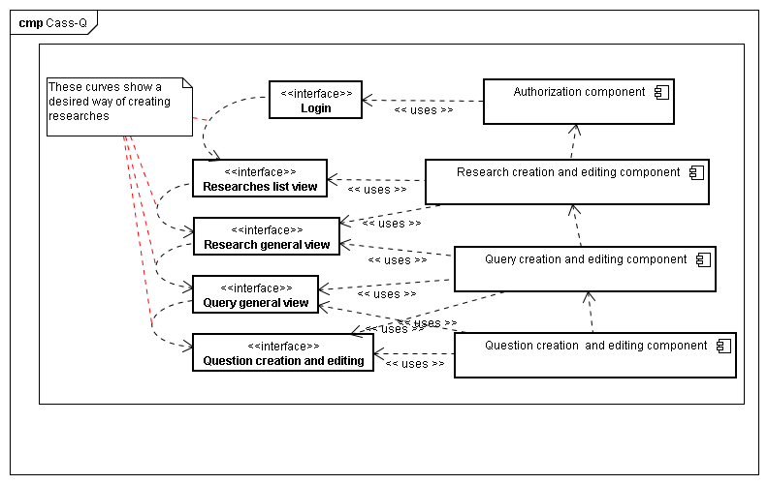
Picture 1
During the authentication and authorization process the Auth class from the PEAR channel is used but for the complete authorization also the User class is used to determine which researches the user is assigned to.
In Picture 1, you can see how these logical components relate to each other. From the top to down, part of each component is used to display the interface.

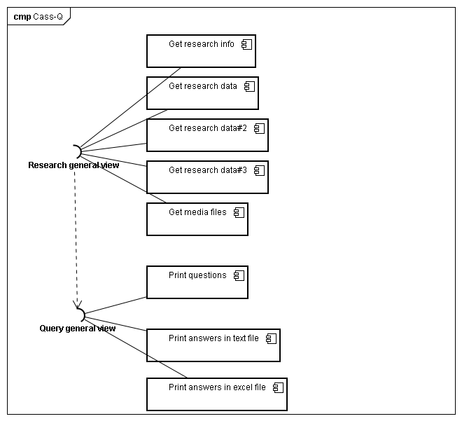
Picture 2
Downloading the collected answers and the questions of the research is possible in two views: in the Research General View and in the Query General View. These components use many classes to retrieve the data.

Business Domain

Domain Models

Business Workflows

Layers & Packages
The Cass-Q Admin system is made in three tier architecture:
- Presentation Logic: it includes files that print the actual content on the screen. This creates the connection between the user of the system and the business logic.
- Business Logic: this is the connection between the presentation processes and the data logic layer.
- Data Logic: this creates the connection to the database.
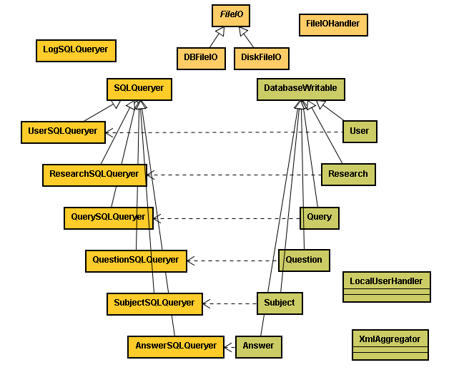
Picture 3: Classes of the data logic and business logic layers

Process View
NA

Overview
NA

Process descriptions
NA

Implementation View
NA

Design Packages
NA

Component Model
NA

Deployment View
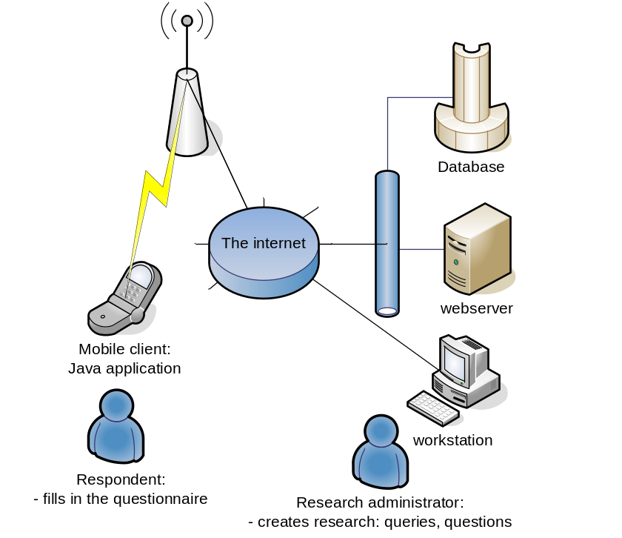

Deployment Unit Structure

Infrastructure components
The Cass-Q system has to be installed to a web server. If during the installation the media storing method was chose to be on the server, then all the media files received from the respondents will be saved into the application’s folder.

The web server has to be connected to a MySQL database.

The respondents answer using the JavaME based mobile application. They connect to the system via internet.

Topology

Data View

Database Explained

Users

Basic user information like: username, password and system administrative rights (super admin, research owner (or research administrator) are saved in table tbl_auth. When inserting a new user to this table, it will get automatically a user identification UID. Users in the Cass-Q Admin are identified by this ID.

System administrative rights are rights to the system. Super administrator has the right to modify, delete or add users. Super admins are the only users which can add new super admins to the system. It is considered that there are not many users with the super administrator rights.

Research owners (changed to Research administrator) are users that can start making new researches to the system. User with this right can also make new research administrators.

These system administrative rights are saved into the database by zeros (0) and ones (1). One in the field stands for that this specific user has the right and zero is not having it. Basic users are those users who have no system administrative rights; they have a zero in both super admin and research owner fields. Basic users cannot log in to the system. Basic user cannot add new users and cannot make new researches.

Table tbl_user_rights is used to link users to researches and to tell the rights inside the research. Its research_id –field tells the research, UID –field tells the user and the subject-, researcher-, and admin –fields tell the rights inside this specific research. Right is on with one (1) and off with zero (0). User can have many of these rights at the same time.

If user has one (1) in the subject –field of table tbl_user_rights a row is generated for that user to the tbl_subject table. This table is basically used to store the Bluetooth ID values for the respondents. tbl_subject table has a field called active. It was supposed to tell if this respondent is in any progressing research or not, but this is handled by looking at the start and end time of a research, so it is considered useless so far.

Researches

Basic research information is stored in tbl_research table. There is the research_id which is used to identify the research. There is also name, description, data collection method, start –and end times, the amount of queries sent a day, creation day and locked value.

There are 4 different (only 3 implemented) data collection methods. In the database they are numbered from 0 to 3.
0: Fixed time –data collection method. In this method times when a query is sent is set. For each time can be made an own query, but same query can also be sent many times a day. Respondents have time to answer the query until next pre-set time kicks in and during this interval; the respondent can answer the query only once. In this data collection method rows are generated into tbl_query_times –table. In this table the times to sent a query is saved. It keeps the research_id, and a query_id information for each time.

1: Fixed Interval –data collection method. In this method a time is set for the days first query, after that the first query can be answered any time. Also there needs to be set an interval. When respondent answers the first query, the time is set to database (tbl_track_fixed). The respondent can answer the next query after the interval has passed (counted by adding the interval to the time when last time answered a query). The order of the queries is stored in a table (tbl_fixed_times). In fixed interval also many different queries can be sent. The time when the first query is sent and the interval are saved in tbl_fixed –table.

2: Event contingent - data collection method. Only one query is sent and it can be answered as many times as the respondent wants to answer it a day. For this data collection method 0 is saved into the queriesperday –field.

3: Random -data collection method. Not implemented. One query sent at random times to respondents as many times as set to system. Maybe it is impossible to implement due to problems with connecting to a phone without end-user activation.

The locked value is used to know if the research is edited by some other user, then its value is the UID of the user editing it. It can also be “freezed” if the lock –button is pressed, after this the research can’t be un-freezed, so nothing can be modified after this.
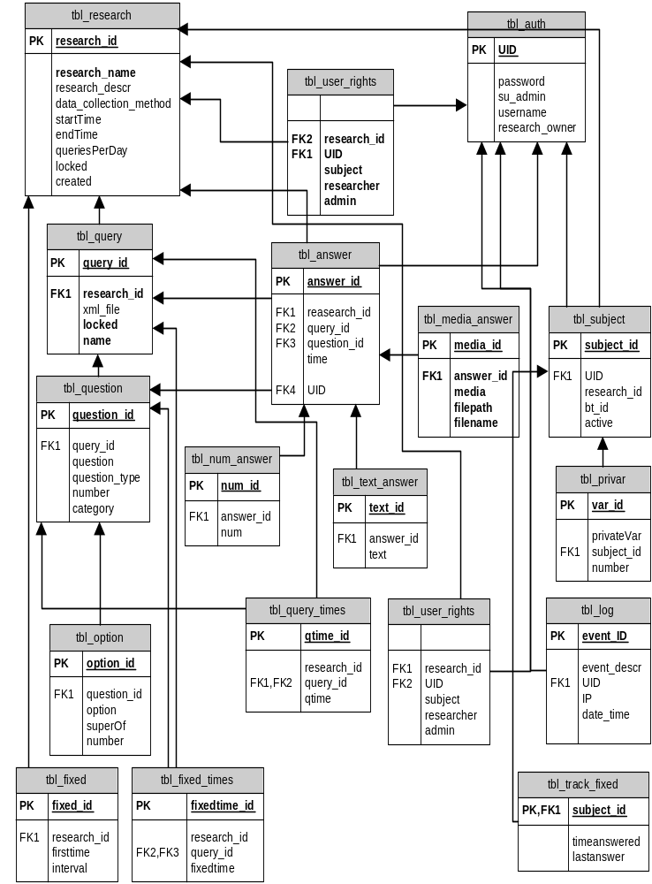

Structure of the Code
The code is separated into folders. The actual pages which are shown to the user are in the content-folder. Those files basically check the authentication and get the content from functionality folder files. They are named the same way so it is easy tell which functionality folder file gives content to content folder files.

AjaxAdd folder has all the JavaScript related code. There is a functions.js file which has almost all the JavaScript functions in it. In dropDownFunctions.js file is the dropdown menu code and the jQuery-plug-in has its own scripts. In the AjaxAdd folder there are the files which create the question editor page and there are the pages where the JavaScript sends data.

Classes
All class files can be found under classes folder. The classes are separated into logic folders; Cass-Q is made in three-tier architecture. Data tier logic is in SQL-IO folder. There are all the files, which make the queries to database. Files are named so that they tell what the database queries is related to. All SQL query classes extend SQLQueryer class, which has the parameters to connect to database.

Logic tier or the business logic is in BusinessLogic folder. Here are the functions which are called from Presentation layer aka the files which show the actual content on the browser. Business logic functions call the data tier functions to get the data from database. In this folder there is a file XMLAggregator.php which is used to create the XML files to the phone and reads the XML which comes from the phone.

The Presentation layer has not been implemented in an ordered manner. The files that would provide the Presentation Logic can mainly be found in the content and functionality folders.

Authorization, Includes
In the common folder there are files that are almost in all files are called. Here you can find the files for the authorization: auth_loginf.php and auth_start.php. These files and the Auth package of the PEAR channel are necessary to perform a valid authorization. Without this, the user is cannot enter the system. The auth_start.php file creates a new Auth object. The start() function checks if there is an existing session and checks its validity. If there is no existing session it creates the login form using the loginFunction that can be found in auth_loginf.php. After a valid Auth object is set up the rest of the pages can be called. This process is repeated in most of the pages.

Also in the common folder can be found the includes.php file. This file contains the reference to all those files that are necessary to be included for the operation of the system. The rest of the files in this folder are not used. They are obsolete or have not been implemented yet.

User Interface
In the UI folder you can find files which are used in the creation of the graphical user interface. The menuGen.php includes a class that builds the menus that can be found on the left side of the pages. Within the layout folder there are more files. The top.php file creates the top part of the page including the dropdown menu and left side navigation menu. The left side menu is build up according to the rights of the user and at what page he/she is at the moment. The bottom.php contains the closing part of the page.

Many parts of the system use the jQuery and jQuery UI JavaScript libraries. The smoothness folder contains the CSS file and the pictures that jQuery scripts use, for example the datepicker, the draggable and the droppable functions (these last ones are part of the editing questions interface).

Communicating with phone
The files that are used in the communication with the mobile phones can be found in the MobileIO folder. When a respondent wants to answer a query, the phone connects to the XMLGen.php file. It gives it a GET parameter “uid”, which is the Bluetooth ID of the phone. That Bluetooth ID needs to be set to a respondent in the research and if so, the file generates the query as an XML-document and the phone downloads it.

When respondent is ready with the query and sends the questions back to the server, it sends the XML document to mobileanswer.php file. Then the XML is parsed and the answers are saved into database. If the query had video, photo or audio-recording questions in it, the media files are sent to mobileMediaFiles.php file. There the filenames are separated from the file and saved into database or into the server based on the settings of the dbsettings.php file.

<?xml version="1.0" encoding="ISO-8859-1"?>
<surveyAnswer>
<timestamp stamp="2008-12-11 15:36:13"/>
<surveyId id="2"/>
<userName name="Jani"/>
<item q_id="1" type="1" answer="ok"/>
<item q_id="2" type="2" answer="10"/>
<item q_id="3" type="3" answer="Subject02_11.12.2008_15.36_2.amr"/>
<item q_id="4" type="4" answer="2"/>
<item q_id="5" type="5" answer="4"/>
<item q_id="7" type="1" answer="dunno"/>
<item q_id="149" type="9" answer="10"/>
<item q_id="3" type="10" answer="3,4,"/>
</surveyAnswer>

Here is a XML, which comes from the phone. There is one answer to almost all of the question types.

Settings and Installation
In the settings folder can be found files related to the setup of the system. Settings, like where the database, the usernames and passwords are, are saved to dbsettings.php. Paths to the media files are also saved in this file, if the files2db variable is set to false.

The dbset.php file is only used during the installation. This is a template file for creating the dbsettings.php file. It is created with the script that can be found in the CreateDb.php. CreateDb.php is called during the installation.

In the installation folder there are files related to the installation process. When the Cass-Q system is installed onto a new server, the install.php script has to be run first. After all the necessary information is given, the script creates a database for storing the data, modify the installation file for the mobile phone and creates a super admin who can later on create other users in the system.

MIDlet-1: CassQ,/kplab.png,midlet.CassQ
MIDlet-Icon: /kplab.png
MIDlet-Jar-Size: 83798
MIDlet-Jar-URL: CassQ.jar
MIDlet-Name: CassQ
MIDlet-Permissions: javax.microedition.io.Connector.http, javax.microedition.media.control.RecordControl, javax.microedition.media.control.VideoControl.getSnapshot
MIDlet-Vendor: Metropolia
MIDlet-Version: 0.81
MicroEdition-Configuration: CLDC-1.1
MicroEdition-Profile: MIDP-2.0
surveyAnswerUrl: http://-server-/MobileIO/mobileanswer.php
surveyAudioUrl: http://-server-/MobileIO/mobileMediaFiles.php
surveyQuestionUrl: http://-server-/MobileIO/XMLGen.php

Here is the CassQ_install.jad that the script changes during the installation process.

Design Constraints

Design Patterns

State Management

Persistence & Data access

Caching

Concurrency &Transactions
During the question making AJAX is used to ease the question creation. To realize a drag and drop method the jQuery JavaScript library is used together with the jQuery UI. AJAX requests are made by these scripts.

Input validation
In the Cass-Q admin system, in the administration sites there are two kinds of validation of the inputs. One is happening on the client side. For this mainly Javascript and a Javascript library, the jQuery is used.
The server side validation is made by the PHP. This appears a bit less times then the client side validation.
In the following comes an enumeration where you can find valdation and what kind of:
- On the login page: the validation and the authorization is made on the server side. The Auth.php package of PEAR PHP plugin validates the login form and authorize the user.
- Add new user: client side validation for the username, password and retype password fields. The validation is made by the validateAdduser() function that can be found in functions.js. The server side validation is made in functionality/adduser_act.php. Both of sides checks if there is a username and retyped password is given. Both of the sides checks if the given passwords match. On the server side the script test if the username already exists in the database.
- Add new research: research name, description, valid date format and the number of the queries is checked on the client side with the validateAddResearch and validateDate functions. After the form is submitted the date format is, the given interval and times are checked depending on the data collection method. Also it is checked if the data collection method is valid.
- Add new query: the name of the query and if the query is assigned to any time or order is checked on the client side. It is checked if there is any free place to assign a new query in the research is checked on the server side.
- Edit query and edit research: the same methods are used as during the creation of them.
- Adding, editing questions: in most of the cases the questions are checked only on the client side. If there is any problem on the server side there comes back only an error message.

Security
The users of the administering sites are identified by usernames and passwords. The authorization is role based. The available roles are:
- Super administrator
- Research administrator
- Researcher
- Respondents
All of these roles are stored in the database. Each role is explained in the 1.3 Definitions, Acronyms, and Abbreviations section. Logging is only possible with the first three roles. The Super administrator does not have access to any researches. The Research administrator role can be assigned by some other Research administrator to a particular research, or the user will get it automatically if he/she created the research. The Researcher role can be assigned only by another Research administrator. In general, all the roles are defined in relation to the actual research; therefore, a user can be Research administrator, a Researcher and a Respondent of a research at the same time.
Super administrator
Research administrator
Research administrator
Researcher
A Super administrator can create users with these roles.
Research administrator
Researcher
Respondent
Super administrator
Research
A Research administrator can create users with these roles.
A Research administrator can create Respondents. They are assigned to a particular research. Respondents can be created only in connection to a research.
After the creation of a Research administrator a Researcher, these user roles can be assigned to research

On the client side for this purpose the Bluetooth id of the mobile phone is used. This is a unique identifier of the phone and it is available for the client application.

Reporting & Printing
Printing the collected data and information is possible generally in two format: excel tables and text files (Rich Text Format or simple Txt file). The following table shows that in what view, in what format the information can be downloaded.
 | Excel table | Text file (RTF) | Text file (TXT)
Research data in the General view of the research | X | - | -
Information about the research in the General view of the research | - | X | -
Print the question in the General view of the query | - | X | -
Print the answers in the General view of the query | X | - | X

